**Statement of Environment Effects**

Demolition of existing structures and Construction of a new dwelling – Dual Occupancy

23 Nella Street, Padstow

**Date:** 8 January 2025

**Revision Number**: 3

**Report Number:** A23-127-250107-SEE

Contents

1 Introduction 2

2 Site Characteristics 3

2.1 Location 3

2.2 Description of the site 4

2.3 Locality of the site 5

3 Proposed work and use 6

3.1 Zoning and Permissibility 6

3.2 Description of proposal and the use of site 6

3.3 Access Parking and Traffic 7

3.4 Waste Management Plan 7

3.5 Electricity, Communication, Gas, Water and Wastewater 8

4 Planning Legislation 8

4.1 Canterbury-Bankstown Local Environmental Plan 2023 8

4.2 Canterbury-Bankstown DCP 2023 11

4.2.1 Chapter 3– General Requirements 11

4.2.2 Chapter 5– Residential Accommodation 15

4.3 Suitability of the Site 19

5 Section 4.15 assessment 19

6 Conclusion 21

# **Introduction**

Design and Approval Pty Ltd have been engaged to prepare a Statement of Environmental Effects Report on behalf of Robin Yasmine.

The Report is submitted to Canterbury-Bankstown Council in support of a development application seeking development consent for the demolition of existing structures and construction of a dual occupancy dwelling at 23 Nella Street, Padstow.

This report describes the site, its environs, the proposed development, and provides an assessment of the environmental impacts and identifies the steps to be taken to protect or reduce the potential impacts on the surrounding environment.

The property is legally described as **Lot 15** Deposited Plan **(DP) 30120**, 23 Nella Street, Padstow.

The client seeks approval for the construction of a dual occupancy dwelling and zoned **R2 – Low Density Residential** under the Canterbury-Bankstown Local Environmental Plan 2023(LEP). The proposal meets the relevant provisions of LEP, DCP and Clause 4.15 of the Environmental Planning and Assessment Act 1979.

# **Site Characteristics**

Based on both a desktop review and an inspection of the site, the following observations were made.

## **Location**

The site is located in a residential area surrounded by other residential accommodation of a similar size and scale. (refer **Figure 1**).

**Figure 1** - Map showing the site in a greater context *(source:* Six Maps <https://maps.six.nsw.gov.au/>*)*

## **Description of the site**

The site address is 23 Nella Street, Padstow, and the property is legally described as Lot 15 Deposited Plan (DP) 30120. It is located within the Canterbury-Bankstown Council local government area (LGA) and is currently zoned **R2 – Low Density Residential** under the Canterbury-Bankstown Local Environmental Plan 2023 (LEP).

**Figure 2** - Map showing the site zoning *(source:* NSW Planning Portal) *https://www.planningportal.nsw.gov.au/spatialviewer/#/find-a-property/address*

The subject site has a consolidated site area of approximately **570.7 m2** with a frontage of

**15.87 m** to Nella Street. The land currently contains a Single Storey Clad Residence, an Awning, and a Clad garage.

## **Locality of the site**

The site is bound by residential buildings of similar scale to the North, East, South, and West.

**Figure 3** – Aerial Photograph *(source:* Google Maps)

# **Proposed work and use**

The client seeks approval for the demolition of existing structures and construction of a dual occupancy dwelling.

## **Zoning and Permissibility**

The subject site is zoned **R2-Low Density Residential** under the Canterbury-Bankstown Local Environmental Plan 2023 (LEP).The proposed development is permissible under the Zone. Dual Occupancies are permissible within the area with consent.

## **Description of proposal and the use of site**

The Client seeks approval for the the demolition of existing structures and construction of dual occupancy. **(Refer to Figure 4 and 5)**.

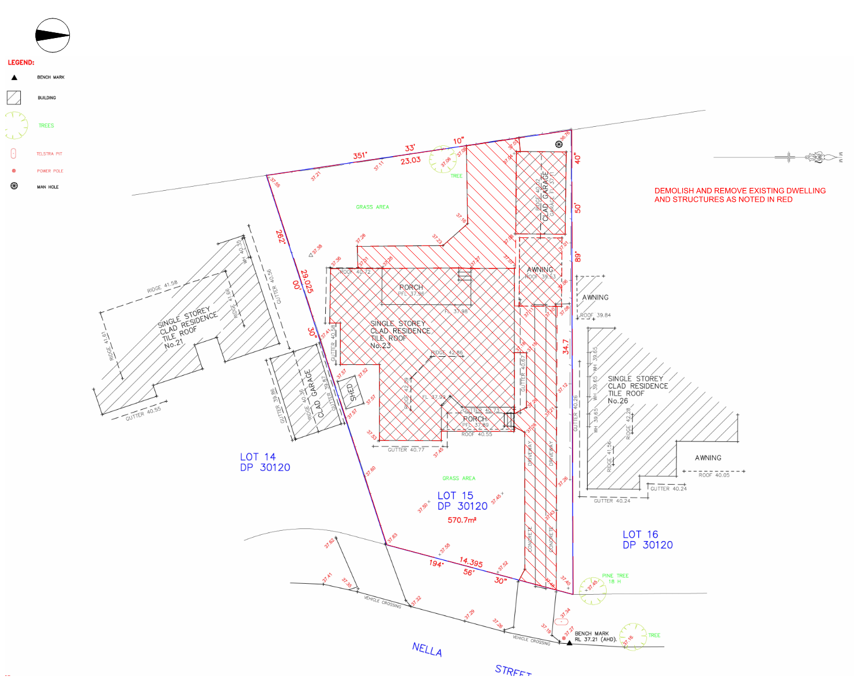

**Figure 4** – Demolition Plan

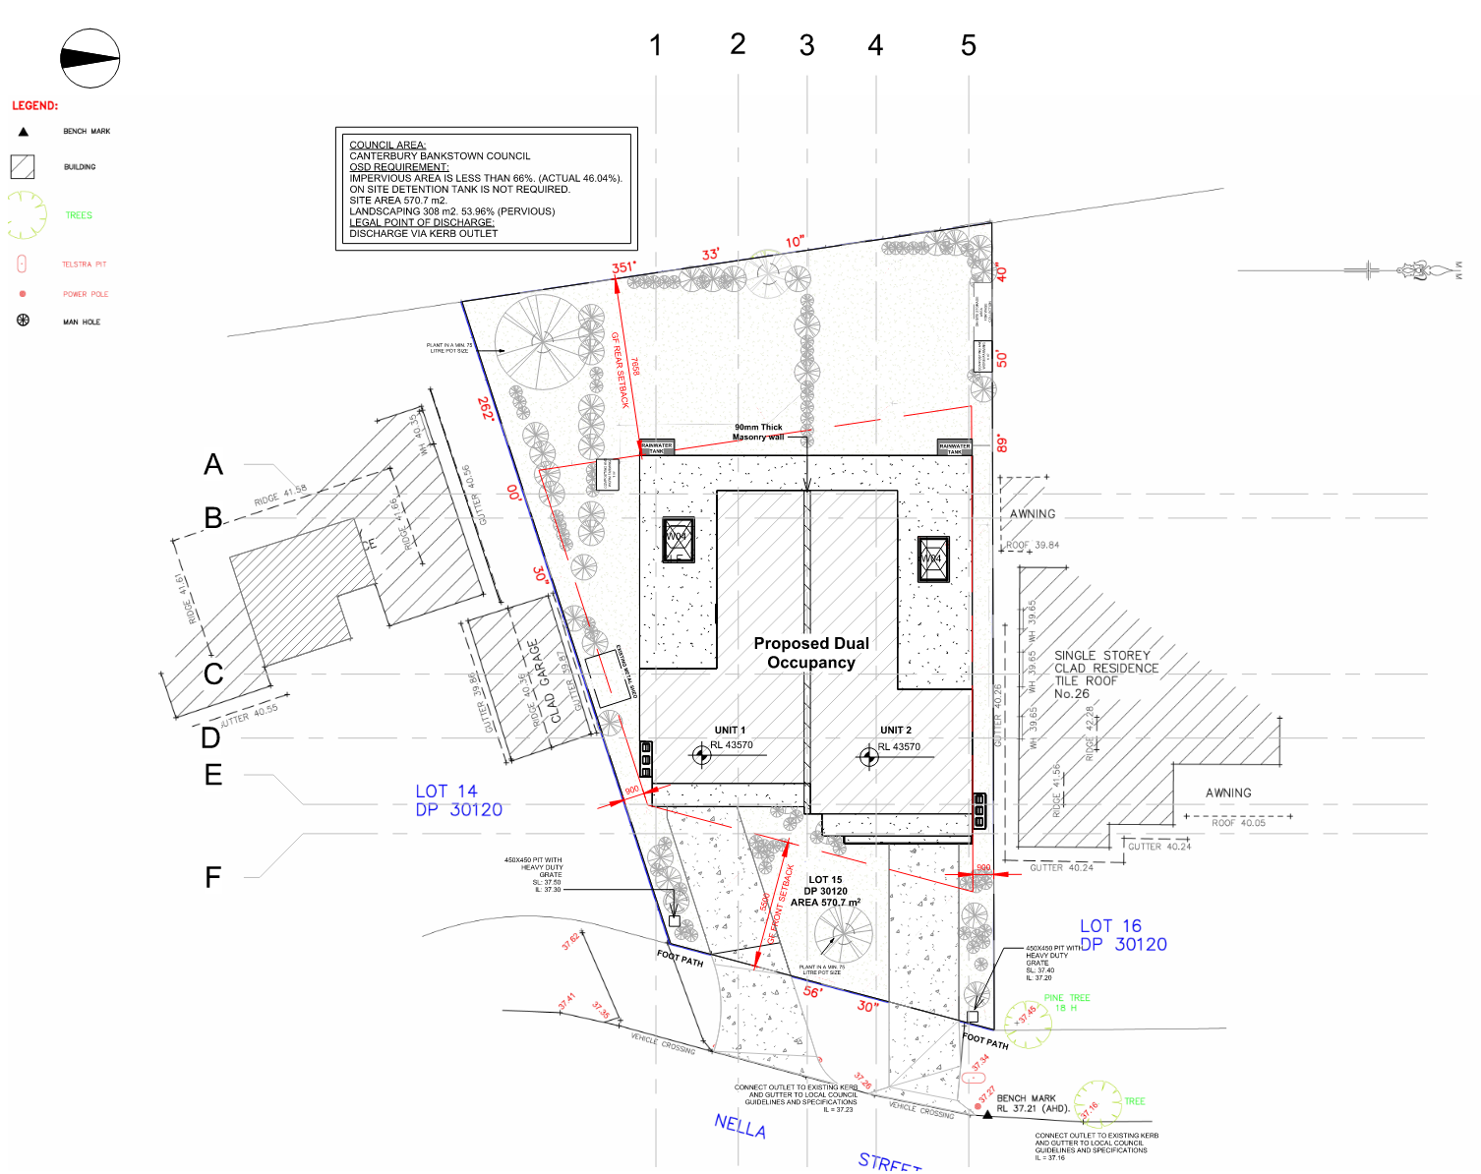**Figure 5** – Proposed site plan

## **Access Parking and Traffic**

The lot has a lawful access from Nella Street, with street access parking.

## **Waste Management Plan**

A waste management plan is submitted in support of the proposal and specifies the steps that will be taken to reduce and avoid waste throughout the construction process and the continued operation of the development.

## **Electricity, Communication, Gas, Water and Wastewater**

The site has provisions already established for service and utility connections.

# **Planning Legislation**

This Section deals with the legislative framework that are relevant to the assessment of this application. The site is affected by various environmental planning instruments and statutory controls as listed below:

## **Canterbury-Bankstown Local Environmental Plan 2023**

Canterbury-Bankstown Local Environmental Plan 2023 (LEP) applies to the subject site, and as such in the first instance, is required to comply with the aims of the LEP, which is as follows: -

***1.2******Aims of Plan***

1. *This Plan aims to make local environmental planning provisions for land in Canterbury-Bankstown in accordance with the relevant standard environmental planning instrument under section 3.20 of the Act.*

*(2) The particular aims of this Plan are as follows—*

*(aa) to protect and promote the use and development of land for arts and cultural activity, including music and other performance arts,*

*(a) to manage growth in a way that contributes to the sustainability of Canterbury-Bankstown,*

*(b) to protect landforms and enhance vegetation, especially foreshores and bushland, in a way that maintains the biodiversity values and landscape amenity of Canterbury-Bankstown,*

*(c) to identify, conserve and protect the Aboriginal, natural, cultural and built heritage of Canterbury-Bankstown,*

*(d) to provide development opportunities that are compatible with the desired future character and amenity of Canterbury-Bankstown,*

*(e) to restrict development on land that is sensitive to urban and natural hazards,*

*(f) to provide a range of residential accommodation to meet the changing needs of the population,*

*(g) to provide a range of business and industrial opportunities to encourage local employment and economic growth and retain industrial areas,*

*(h) to create vibrant town centres by focusing employment and residential uses around existing centres and public transport,*

*(i) to provide a range of recreational and community service opportunities and open spaces to meet the needs of residents of and visitors to Canterbury-Bankstown,*

*(j) to achieve good urban design in terms of site layouts, building form, streetscape, architectural roof features and public and private safety,*

*(k) to ensure activities that may generate intensive car usage and traffic are located near public transport that runs frequently to reduce dependence on cars and road traffic,*

*(l) to consider the cumulative impact of development on the health of the natural environment and waterways and on the capacity of infrastructure and the road network,*

*(m) to support healthy living and enhance the quality of life and the social well-being and amenity of the community,*

*(n) to ensure development is accompanied by appropriate infrastructure,*

*(o) to promote ecologically sustainable development.*

The subject site is zoned **R2 – Low Density Residential** as illustrated in **Figure 2 and 3** above, the proposed development is permissible under the zone with consent.

In addition to the aims of Canterbury-Bankstown LEP, and the zoning, the proposal is required to comply with the objectives for the specific zoning and the objectives for **R2** have been assessed and tabulated as follows: -

|  |  |  |
| --- | --- | --- |
| **LEP Provision** | **Comment** | **Compliance** |
| **Zone R2   Low Density Residential** | **1**   **Objectives of zone**  •   To provide for the housing needs of the community within a low density residential environment.  • To enable other land uses that provide facilities or services to meet the day to day needs of residents.  • To allow for certain non-residential uses that are compatible with residential uses and do not adversely affect the living environment or amenity of the area.  • To ensure suitable landscaping in the low density residential environment.  • To minimise and manage traffic and parking impacts.  • To minimise conflict between land uses within this zone and land uses within adjoining zones.  • To promote a high standard of urban design and local amenity | The proposal strongly aligns with the objectives as listed in the **Zone R2** land use table. |
| **Zone R2   Low Density Residential** | **3**   **Permitted with consent**  Bed and breakfast accommodation; Building identification signs; Business identification signs; Car parks; Centre-based child care facilities; Community facilities; **Dual occupancies**; Dwelling houses; Early education and care facilities; Environmental facilities; Environmental protection works; Exhibition homes; Flood mitigation works; Group homes; Health consulting rooms; Home businesses; Oyster aquaculture; Places of public worship; Pond-based aquaculture; Recreation areas; Respite day care centres; Roads; Secondary dwellings; Semi-detached dwellings; Tank-based aquaculture | Dual Occupancies are permitted with consent in the subject zone |
| **4.1 Minimum subdivision lot size** | (1)  The objectives of this clause are as follows—  (a)  to ensure lots are large enough to accommodate proposed dwellings, setbacks to adjoining land, private open space and landscaped areas, driveways and vehicle manoeuvring areas,  (b)  to ensure the subdivision of low density residential zoned land reflects and reinforces the predominant subdivision pattern of the area,  (c)  to ensure lots can be used for buildings that are safe from flooding, bush fire risk and other hazards,  (d)  to ensure lots are large enough to protect special attributes, including natural or cultural features, heritage items, heritage conservation areas, trees and natural topographical features,  (e)  to ensure all lots are provided with adequate and safe access,  (f)  to minimise the likely adverse impact of subdivision and development on the amenity of the area,  (g)  to prevent fragmentation or isolation of land. | There is no proposed subdivision. |
| **4.3**   **Height of buildings** | The maximum height shown on the Height Building Map is **9m.** | Proposed maximum development height is 6.5m. |
| **4.4**   **Floor space ratio** | Maximum FSR shown on Floor Space Ratio Map is **0.5:1** | Gross floor: 236.79 m2  Site area: 570.7 m2  FSR: 0.4:1  Yes |
| **5.21**   **Flood planning** | (1) The objectives of this clause are as follows—  (a) to minimise the flood risk to life and property associated with the use of land,  (b) to allow development on land that is compatible with the flood function and behaviour on the land, taking into account projected changes as a result of climate change,  (c) to avoid adverse or cumulative impacts on flood behaviour and the environment,  (d) to enable the safe occupation and efficient evacuation of people in the event of a flood. | The proposed development is not located in a flood risk Zone |
| **6.1 Acid Sulfate soils** | (1) The objective of this clause is to ensure that development does not disturb, expose or drain acid sulfate soils and cause environmental damage.  (2) Development consent is required for the carrying out of works described in the table to this subclause on land shown on the Acid Sulfate Soils Map as being of the class specified for those works.  *Class 1 - Any works.*  *Class 2 - Works below the natural ground surface. Works by which the watertable is likely to be lowered.*  *Class 3 - Works more than 1m below the natural ground surface. Works by which the watertable is likely to be lowered more than 1m below the natural ground surface.*  *Class 4 - Works more than 2m below the natural ground surface. Works by which the watertable is likely to be lowered more than 2m below the natural ground surface.*  ***Class 5 - Works within 500m of adjacent Class 1, 2, 3 or 4 land that is below 5m Australian Height Datum and by which the watertable is likely to be lowered below 1m Australian Height Datum on adjacent Class 1, 2, 3 or 4 land.***  (3) Development consent must not be granted under this clause for the carrying out of works unless an acid sulfate soils management plan has been—  (a) prepared for the proposed works in accordance with the Acid Sulfate Soils Manual, and  (b) provided to the consent authority.  (4) Development consent is not required under this clause for the carrying out of works if—  (a) a preliminary assessment of the proposed works prepared in accordance with the Acid Sulfate Soils Manual indicates that an acid sulfate soils management plan is not required for the works, and  (b) the preliminary assessment has been provided to the consent authority, and  (c) the consent authority has confirmed the assessment by notice in writing to the person proposing to carry out the works.  (5) Development consent is not required under this clause for the carrying out of the following works by a public authority, including ancillary work such as excavation, construction of access ways or the supply of power—  (a) emergency work that involves the repair or replacement of the works of the public authority, required to be carried out urgently because the works—  (i) have been damaged, or  (ii) have ceased to function, or  (iii) pose a risk to the environment or to public health and safety,  (b) routine maintenance work that involves the periodic inspection, cleaning, repair or replacement of the works of the public authority, other than work that involves the disturbance of more than 1 tonne of soil,  (c) minor work that costs less than $20,000, other than drainage work.  (6) Development consent is not required under this clause to carry out works that—  (a) involve the disturbance of less than 1 tonne of soil, and  (b) are not likely to lower the watertable. | Proposed Development is located in class 5 Land.  Refer to Acid Sulfate Management Plan. |

## **Canterbury-Bankstown DCP 2023**

### **Chapter 3– General Requirements**

|  |  |  |
| --- | --- | --- |
| **DCP Provision** | **Controls** | **Compliance** |
| **3.2 Parking** | | |
| **Section 2 – Off-street parking rates** | | |
| **Off-Street Parking Schedule** | 1 car space per 2 or less bedrooms; or 2 car spaces per 3 or more bedrooms | 1 car space provided for each dwelling with 2 bedrooms |
| **Section 3 – Design and layout** | | |
| **Parking location** | Development must not locate entries to car parking or delivery areas:  (a) close to intersections and signalised junctions;  (b) on crests or curves;  (c) where adequate sight distance is not available;  (d) opposite parking entries of other buildings that generate a large amount of traffic (unless separated by a raised median island);  (e) where right turning traffic entering may obstruct through traffic;  (f) where vehicles entering might interfere with operations of bus stops, taxi ranks, loading zones or pedestrian crossings; or  (g) where there are obstructions which may prevent drivers from having a clear view of pedestrians and vehicles. | Garages have been designed taking into consideration the mentioned points. |
| **Access driveway width and design** | 3.11 For new residential development, necessary clear driveway widths are provided in the following table:  **Driveway width Minimum clear width**  One-way 3m Two-way 5.5m | One-way driveway is proposed of 3m width |
| **Minimum headroom dimensions** | 3.12 Clear headroom dimension is necessary to make sure that vehicles are clear of mechanical or service obstructions such as fire sprinklers, lighting fixtures and signs. The following minimum headroom dimension must be maintained in all development.    **Minimum headroom Dimension**  Cars and light vans 2.4m  People with disabilities 2.3m  Small rigid vehicles 3.6m | The clear headroom of the proposed garages is 2.5 meters, which complies with the first two requirements. Small rigid vehicle garages are more commonly used for commercial purposes, which is not applicable in this case. |
| **Safety and security** | 3.18 Sloping ramps from car parks, garages and other communal areas are to have at least one full car length of level driveway before they intersect pavements and carriageways. | The sloping ramp from the garage has at least one full car length of level driveway. |
| **Sight distance requirements** | 3.19 For all development, adequate sight distance must be provided for vehicles exiting driveways. Clear sight lines are to be provided at the street boundary to ensure adequate visibility between vehicles on the driveway and pedestrians on the footway and vehicles on the roadway. | Clear sight lines are provided at the street boundary. |
| **3.3 Waste Management** | | |
| **Section 3 – Residential Development** | | |
| **All residential development types** | 3.1 Council or its contractors are solely to provide the waste services to all residential development types as required under the Local Government Act 1993. | Waste services are provided as per the requirement. |
|  | 3.2 Each dwelling is to have:  (a) A waste storage cupboard in the kitchen capable of holding two days waste and recycling and be sufficient to enable separation of recyclable materials.  (b) A suitable space in the kitchen for a caddy to collect food waste. | Waste storage cabinet and food waste collection are provided in the kitchen  Refer to Architectural Drawings |
|  | 3.3 Development must provide an adequate sized bin storage area behind the front building line to accommodate all allocated bins. | Bin storage area is provided behind the building lime  Refer to Architectural drawings |
|  | 3.4 The location of the nominated collection point and bin storage area must not adversely impact on the streetscape, building design or amenity of dwellings. | The location of the nominated collection point and bin storage area is carefully chosen to ensure it does not significantly affect the public domain. It will be screened appropriately, making it the most suitable location. |
|  | 3.5 The location of the bin storage area should ensure this area:  (a) is screened or cannot be viewed from the public domain; and  (b) is away from windows of habitable rooms to reduce adverse amenity impacts associated with noise, odour and traffic. | Waste bins are screened and away from habitable room windows |
|  | 3.6 The location of the bin storage area is to be convenient to use for the dwelling occupants and caretakers, through reducing the bin travel distance from the bin storage area to the nominated kerbside collection point. The bin-carting route from the bin storage area to the collection point must not pass through any internal areas of the building/dwelling and must avoid stairs or slopes. | The bin storage area is convenient for use, has minimal travel distance to the kerbside collection point, and the bin-carting route avoids internal areas, stairs, and slopes. |
|  | 3.7 Where possible, development may consider providing each dwelling with a suitable space for composting and worm farming, located within the backyard, private courtyard or open space. Composting facilities should locate on an unpaved area, with a minimum size of 1m2 per dwelling. | Each dwelling has a 1m² composting facility provided at the rear. |
|  | 3.8 Dwellings are to have access to an adequately sized on-site storage area to store bulky waste awaiting collection. | On site storage area for bulky wastes are provided.  Refer to Architectural drawings |
|  | 3.9 Development must comply with the requirements of the applicable Waste Design for New Developments Guide. | Refer to waste management plan |
|  | 3.10 Council cannot provide a collect and return service at locations where waste collection vehicles are not permitted to stop in accordance with road rules. | Refer to waste management plan |
| **3.7 Landscape** | | |
| **Section 2 – Landscape design** | | |
| **Existing vegetation and natural features** | 2.1 New landscaping is to complement the existing street landscaping and improve the quality of the streetscape. | The new landscaping complements the existing street landscaping and enhance the quality of the streetscape. |
| 2.2 Development, including alterations and additions, is to minimise earthworks (cut and fill) in order to conserve site soil. Where excavation is necessary, the reuse of excavated soil on site is encouraged. | Earthworks, including cut and fill, have been minimized to the greatest extent possible to conserve site soil. |
| **Design and location of landscape** | 2.3 The landscape design is to contribute to and take advantage of the site characteristics. | Site characteristics have been taken into consideration when designing the landscape |
| 2.4 The landscape design is to improve the quality of the streetscape and communal open spaces by:  (a) providing appropriate shade from trees or structures;  (b) defining accessible and attractive routes through the communal open space and between buildings;  (c) providing screens and buffers that contribute to privacy, casual surveillance, urban design and environmental protection, where relevant; Page 6 DCP 2023–Chapter 3.7 (Amended August 2024)  (d) improving the microclimate of communal open spaces and hard paved areas;  (e) locating plants appropriately in relation to their size including mature size;  (f) softening the visual and physical impact of hard paved areas and building mass with landscaping that is appropriate in scale;  (g) including suitably sized trees, shrubs and groundcovers to aid climate control by providing shade in summer and sunlight in winter. | The landscape has been designed taking into consideration all these points.  Refer to drawings |
| **Trees** | 2.6 Development must consider the retention of existing trees, including street trees, in the building design. | Existing trees are retained |
| 2.7 Development must plant at least one canopy tree for every 12m of front and rear boundary width and:  (a) Canopy trees are to be of a minimum 75 litre pot size.  (b) Use deciduous trees in small open spaces, such as courtyards, to improve solar access and control of microclimate.  (c) Place evergreen trees well away from the building to allow the winter sun access.  (d) Select trees that do not inhibit airflow.  (e) Provide shade to large hard paved areas using tree species that are tolerant of compacted/deoxygenated soils. | Tree planting requirements have been taken into consideration for the development.  Refer to Landscape Plan |
| 2.8 Development must provide street trees that will contribute to the canopy where possible. | Provided |

### **Chapter 5– Residential Accommodation**

**5.1 Former Bankstown LGA**

***Application of this Chapter***

*Chapter 5.1 of this DCP applies to residential accommodation within the former Bankstown Local Government Area.*

***Desired Character***

***C1 Low density residential areas***

*The desired character is to have a low-density residential environment in Zone R2 where the typical features are dwelling houses, dual occupancies, secondary dwellings, and ancillary development within a generous landscaped setting. The site cover and building form of development must be compatible with the prevailing suburban character and amenity of this zone. This zone is also the most restrictive in terms of other permitted uses that are considered suitable. These are generally restricted to facilities and services that meet the day-to-day needs of residents.*

|  |  |  |
| --- | --- | --- |
| **DCP Provision** | **Controls for Dwelling Houses** | **Compliance** |
| **Section 4 – Dual occupancies** | | |
| **Subdivision** | 4.1 For development that establishes a dual occupancy and a secondary dwelling on the same allotment, the two dwellings forming the dual occupancy may be subdivided provided the minimum lot size is 450m2 per dwelling. | N/A. No subdivision is proposed |
| **Storey limit (not including basements)** | 4.2 The storey limit for dual occupancies is two storeys. | The dual occupancy proposed constitutes of 2 storeys. |
| 4.3 The siting of dual occupancies, and landscape works must be compatible with the existing slope and contours of the site and any adjoining sites. Council does not allow any development that involves elevated platforms on columns; or excessive or unnecessary terracing, rock excavation, retaining walls or reclamation. | None of these elements are proposed. |
| **Fill** | 4.4 Any reconstituted ground level on the site within the ground floor perimeter of dual occupancies must not exceed a height of 1m above the ground level (existing). For the purposes of this clause, the ground floor perimeter includes the front porch. | The proposed ground floor level does not exceed 1m above NGL. |
| 4.5 Any reconstituted ground level on the site outside of the ground floor perimeter of dual occupancies must not exceed a height of 600mm above the ground level (existing) of an adjoining site. For the purposes of this clause, the ground floor perimeter includes the front porch. | The proposed ground level outside the dual occupancy has a minimal height above the natural ground level. |
| **Setback restrictions** | 4.6 The erection of dual occupancies is prohibited within 9m of an existing animal boarding or training establishment | N/A |
| **Street setbacks** | 4.7 The minimum setback for a building wall to the primary street frontage is:  (a) 5.5m for the first storey (i.e. the ground floor); and  (b) 6.5m for the second storey. | Proposed:  GF: 5.5m  FF: 6.5m |
| 4.8 The minimum setback to the secondary street frontage is: (a) 3m for a building wall; and  (b) 5.5m for a garage or carport that is attached to the building wall. | N/A |
| **Side setbacks** | 4.9 The minimum setback for a building wall to the side boundary of the site is 0.9m. Council may increase the minimum setback to reduce any impact on the amenity of an adjoining dwelling or to avoid the drip line of a tree on an adjoining site. | Side setback :0.9m |
| 4.10 The minimum setback between a dual occupancy and the side boundary must be clear of obstacles such as a hot water unit, waste storage area, storage shed and the like. The intended outcome is to provide a clear path at all times for residents and visitors to access the rear yard and/or carry out maintenance works. | Waste bins for unit 2 have been placed within the side setback because this is the optimal placement in terms of a short path for accessibility and being far from windows. Therefore, placing the bins at the rear, which is the w other option based on the design, would not comply with waste storage requirements. |
| 4.11 The basement level must not project beyond the ground floor perimeter of the dual occupancy. For the purposes of this clause, the ground floor perimeter includes the front porch. | N/A. No basement is proposed. |
| **Private open space** | 4.12 Dual occupancies must provide a minimum 80m2 of private open space per dwelling behind the front building line. This may be in the form of a single area or a sum of areas per dwelling provided the minimum width of each area is 5m throughout. | PPOS  80m2 for each dwelling/behind front building line  >5mwidth |
| **Access to sunlight** | 4.13 At least one living area of each dwelling must receive a minimum three hours of sunlight between 8.00am and 4.00pm at the mid-winter solstice. Council may allow light wells and skylights to supplement this access to sunlight provided these building elements are not the primary source of sunlight to the living areas. | Skylights have been placed above the living areas in each dwelling, allowing sunlight to enter. |
| 4.14 At least one living area of a dwelling on an adjoining site must receive a minimum three hours of sunlight between 8.00am and 4.00pm at the mid-winter solstice. Where this requirement cannot be met, the development must not result with additional overshadowing on the affected living areas of the dwelling. | The Living area of each adjoining dwelling receives more than three hours of sunlight between 8.00 am and 4.00pm |
| 4.15 A minimum 50% of the private open space required for each dwelling and a minimum 50% of the private open space of a dwelling on an adjoining site must receive at least three hours of sunlight between 9.00am and 5.00pm at the equinox. Where this requirement cannot be met for a dwelling on an adjoining site, the development must not result with additional overshadowing on the affected private open space. | More than 50% of the PPOS of the dwellings and the adjoining dwellings receive a minimum three hours of sunlight between 9.00am and 5.00pm |
| 4.16 Development should avoid overshadowing any existing solar hot water system, photovoltaic panel or other solar collector on the site and neighbouring sites. | The development does not overshadow the solar panels on the adjoining dwelling during peak hours of solar access |
| **Visual privacy** | 4.17 Where development proposes a window that directly looks into the living area or bedroom window of an existing dwelling, the development must:  (a) offset the windows between dwellings to minimise overlooking; or  (b) provide the window with a minimum sill height of 1.5m above floor level; or  (c) ensure the window cannot open and has obscure glazing to a minimum height of 1.5m above floor level; or  (d) use another form of screening to the satisfaction of Council. | N/A |
| 4.18 Where development proposes a window that directly looks into the private open space of an existing dwelling, the window does not require screening where:  (a) the window is to a bedroom, bathroom, toilet, laundry, storage room, or other non-habitable room; or  (b) the window has a minimum sill height of 1.5m above floor level; or  (c) the window has translucent glazing to a minimum height of 1.5m above floor level; or  (d) the window is designed to prevent overlooking of more than 50% of the private open space of a lower-level or adjoining dwelling. | N/A |
| 4.19 Council may allow dual occupancies to have an upper floor side or rear balcony solely where the balcony is not accessible from a living area or hallway, and the balcony design:  (a) does not have an external staircase; and  (b) does not exceed a width of 1.5m throughout; and  (c) incorporates a form of screening to the satisfaction of Council such as partially recessing the balcony into the building. | N/A |
| 4.20 Council does not allow dual occupancies to have roof-top balconies and the like | The proposed dual occupancy doesn’t have a roof top balcony and the like. |
| **Building design** | 4.21 Development for the purpose of dual occupancies must demolish all existing dwellings (not including any heritage items) on the site. | All existing structures are demolished |
| 4.22 The design of dual occupancies must ensure:  (a) the street facade of dual occupancies (attached) adopt an asymmetrical design to provide each dwelling with an individual identity when viewed from the street; or  (b) the street facade of dual occupancies (attached) or dual occupancies (detached) incorporate architectural elements that are compatible with the asymmetrical appearance of neighbouring dwelling houses, particularly where a pattern is established by a group of adjoining dwelling houses; and (c) the front porch and one or more living area or bedroom windows to each dwelling face the street; and  (d) the garage, driveway and front fence do not dominate the front of the building and front yard; and  (e) the two dwellings on a corner site each face a different frontage. | The design of the dual occupancy complies with all these points.  Refer to the architectural drawings |
| 4.23 The maximum roof pitch for dual occupancies is 35 degrees. | The proposed dual occupancy has a flat roof. |
| 4.24 Council may allow dual occupancies to have an attic provided the attic design:  (a) accommodates no more than two small rooms (for the purposes of a bedroom and/or study) and a bathroom plus an internal link to the storey below; and  (b) ensures the attic does not give the external appearance of a storey. | N/A |
| 4.25 The design of dormers must:  (a) be compatible with the form and pitch of the roof; and  (b) must not project above the ridgeline of the main roof; and (c) must not exceed a width of 2m; and  (d) the number of dormers must not dominate the roof plane. | N/A |
| 4.26 Development in the foreshore protection area (refer to map in Appendix 1) must use non-reflective materials that are compatible with the natural characteristics and colours of the area (such as olive green, grey and dark brown). | Non-reflective materials have been used for the development, given that it is in a foreshore protection area. |
| **Building design (car parking)** | 4.27 Development on land bounded by Birdwood Road, Bellevue Avenue and Rex Road in Georges Hall must:  (a) comply with the road pattern shown in Appendix 2; and (b) ensure vehicle access from Balmoral Crescent to land at 107–113 Rex Road in Georges Hall is provided for no more than 10 dwellings as shown in Appendix 3. | N/A |
|  | 4.28 Development must locate the car parking spaces behind the front building line with at least one covered car parking space for weather protection. Despite this clause, Council may allow one car parking space per dwelling to locate forward of the front building line provided:  (a) the car parking space forward of the front building line is uncovered and located in a stacked arrangement on the driveway in front of the covered car parking space; and  (b) the covered car parking space is setback a minimum 6 metres from the primary and secondary street frontages. | The irregular shape of the lot necessitated a design where one garage has a setback from the building line, while the other garage has a 0 setback from the building line with a 5.5m setback from the street. This design choice was made to optimize the use of space and accommodate the lot shape, which did not allow for greater flexibility |
|  | 4.29 Where development proposes a garage with up to two car parking spaces facing the street, Council must ensure the garage architecturally integrates with the development and does not dominate the street facade. Council does not permit internal stacked or tandem garages. | N/A |
|  | 4.30 Where development proposes a garage with more than two car parking spaces facing the street, Council must consider the architectural merit of the development and may allow the garage provided:  (a) the building is at least two storeys in height, and  (b) the garage is architecturally integrated with the upper storey by:  (i) ensuring the garage does not project more than 3m forward of the upper storey street facade; and  (ii) designing a covered balcony, rooms or other architectural features of the upper storey to extend over the garage roof.  This clause prevails where there is a numerical inconsistency with another clause in this chapter of the DCP. | N/A |
| **Landscape** | 4.31 Development must retain and protect any significant trees on the site and adjoining sites. To achieve this clause, the development may require a design alteration or a reduction in the size of the dual occupancy. | Existing trees have been retained. |
|  | 4.32 Development must landscape the following areas on the site by way of trees and shrubs with preference given to native vegetation endemic to Canterbury-Bankstown (refer to the Landscape Guide for a list of suitable species):  (a) a minimum 45% of the area between the dual occupancy and the primary street frontage; and  (b) a minimum 45% of the area between the dual occupancy and the secondary street frontage; and  (c) plant at least one 75 litre tree between the dual occupancy and the primary street frontage (refer to the Landscape Guide for a list of suitable trees in Canterbury-Bankstown); and  (d) for development in the foreshore protection area (refer to map in Appendix 1), plant native trees with a mature height greater than 12m adjacent to the waterbody. | (a)> 45% has been landscaped in the area between the dual occupancy and the front boundary  (c)A 75 litre tree has been planted in this area  (d) Several native trees have been planted but less than 12m height given that the lot is not adjacent to a waterbody but within the foreshore protection area.  Refer to Landscape Plan |

## **Suitability of the Site**

The subject site is zoned **R2 Low Density Residential**. The proposal strongly aligns with the objectives of the zone. Furthermore, the proposal is considered appropriate as it is surrounded by similar buildings/structures of a similar size. As such it is considered that the development is suitable for the site and the surrounding area.

# **Section 4.15 assessment**

The proposed development has been assessed against the relevant matters for consideration under Section 4.15 (Previously 79C) of the *Environmental Planning and Assessment (EP&A) Act 1979* and no concerns have been identified that would validate the refusal of the application based upon planning grounds. Outlined below is a brief assessment of the proposal with regards to Section 79C of the EP&A Act 1979.

*(1)* ***Matters for consideration—general***

*In determining a development application, a consent authority is to take into consideration such of the following matters as are of relevance to the development the subject of the development application:*

*(a) the provisions of:*

*(i)*  *Any environmental planning instrument*

This Statement of Environmental Effects has shown that this proposal is permissible with consent and complies with the relevant provisions of the LEP.

*(ii)* *any proposed instrument that is or has been the subject of public consultation under this Act and that has been notified to the consent authority (unless the Director-General has notified the consent authority that the making of the proposed instrument has been deferred indefinitely or has not been approved), and*

There are no draft environmental planning instruments currently on display that relate to this site.

*(iii)*  *any development control plan*

The proposed development complies with the provisions of the Development Control Plan.

*(iiia)  any planning agreement that has been entered into under section 93F, or any draft planning agreement that a developer has offered to enter into under section 93F, and*

*(iv)* *the regulations (to the extent that they prescribe matters for the purposes of this paragraph),*

*b) the likely impacts of the development, including environmental impacts on both the natural and built environments, and social and economic impacts in the locality*

* Impact on Water:

No impact on water is proposed.

* Impact on Soil:

No effect on the soil as there are no proposed hard stand works to the existing soft ground areas.

* Impact on Flora and Fauna:

No effect or impact upon the existing biodiversity of the local area or critical habitats, threatened or endangered species, populations, ecological communities and their habitats.

* Impact on Air Quality:

No impact on air quality.

* Noise Pollution:

Being in a Residential area, the noise generated would not be at a level not expected from such an area.

* Traffic Impact:

It is considered that the car parking arrangements satisfactorily comply with the objectives of the DCP.

* Visual Impact:

The demolition of the existing structures and the construction of a dual occupancy will not affect the visual impact as the new development is designed to integrate seamlessly with the existing neighborhood's architectural style, height, scale, and incorporates adequate setbacks and landscaping.

* Social and Economic Impact:

The proposal is not likely to result in any adverse social or economic impacts.

*(c)*  *the suitability of the site for the development*

The site is considered suitable for the proposed development as it complies with the objectives of Canterbury-Bankstown Local Environmental Plan 2023.

*(d) any submissions made*

If the proposal is notified by Council, any submissions received will be considered by Council.

*(e)* *the public interest*

The proposed use will not create any significant adverse impacts on neighbouring properties. The development is both consistent with and complimentary to the nature, character and scale of the residential area. Given the above, the proposal is considered to be in the public interest.

# **Conclusion**

Based on the information above and our investigation of the relevant planning controls, it is concluded that the proposed development is consistent with the objectives, planning strategies and requirements of the LEP and DCP.

It is requested that consideration be granted to this application based on the individual merits of the proposal, including the suitability of the site for the development and the absence of any adverse impacts associated with the proposed development.